**WORK INSTRUCTIONS FOR_HBS AND BLOWERS OPERATION (BF1 & BF2**)

**Blower Operation**

Responsibility: Control Room Engineer

**Identified Hazards:**

1. BF Gas poisoning
2. Fall of person causing injury
3. Fire & Explosion
4. Human behavior -Nonuse of PPE , WI
5. Improper house keeping
6. Inadequate local lighting
7. Forgetting what the sequence was of opening the valve.
8. Attack by bees/insects
9. Incomplete isolation process (Zero energy state not ensured)
10. Contacts with the Hot surface.
11. Contact with the hot Blast.
12. Pressure in the line
13. Mechanical impact
14. Noise
15. Wrong damper operation due to absent mind
16. Human behaviour- doing the job in hurry
17. BF Gas poisoning
18. Fall of person causing injury
19. Fire & Explosion
20. Non use of PPE
21. Improper house keeping
22. Inadequate local lighting
23. Forgetting what the sequence was of opening the valve
24. Attack by bees/insects
25. Valve failure due to oil Leakage
26. Incomplete isolation process (Zero energy state not ensured)

**Significant Aspects:**

1. Noise generation

**Procedure:**

1. Unauthorized operation or repair of any equipment is a punishable offence

2. Persons who are going to start / stop blowers in blower house must use earmuffs while moving around the area.

3. The sign boards should be displayed at prominent places in the blower house.

4. Ensure there is no leakage at the dampers.

5. Ensure that the maximum available wind volume is maintained with cold blast pressure 1.40Kg/cm2 in BF#1 & BF#2. Starting 5th Blowers with increased cold blast Pressure to 1.51 kg/cm2 whenever furnace hunting is noticed with mechanical HOD clearance and proper information to instrumentation & electrical

6. Measure the noise level once in a month.

**Auto Blower No.1 starting in Furnace 1 & 2 in case of power failure.**

1. Ensure Inlet manual damper of blower no1 should be open.

2. Ensure Motorized Bypass damper of blower no1 should be open.

3. Ensure Motorized Outlet damper of blower no1 should be close.

4. Ensure New line manual damper should be open.

5. Ensure Motorized New line electrical damper should be close.

**BF 1 & II BLOWER NO- 1 AUTO STARTING**

1. As soon as power failure occurs on 11 kV panel, an auto Command will go to CAT DG - 1 for starting. DG will crank & will go to high idle speed in auto. Once DG is in high idle & voltage is developed CAT 1 breaker will close in auto and power supply will resume at all locations. This process will take around 42 secs

2. Automatic starting command will go to DG when power failure occurs provided; 1) Cat panel Auto/ manual S/W is in auto mode 2) High / low idle Switch on CAT-1 panel in auto, 3) No 11 kV bus supply.

3. 11 kv DG Breaker will close in auto provided, 1) No11 kV bus supply 2) Cat DG voltage developed, 3) Engine in high idle, 4) GEPL incomer breaker is OFF.

4. Once BF1 3.3KV bus is charged, HBS PLC will sense 3.3 kV bus PT supply OFF and ON command and thus BF I Blower-1 will get a start command from HBS PLC. For blower-1 to start in auto following condition should be satisfied.1) Blower-1 local / Remote switch is in remote mode, 2) Blower 1 breaker spring is in charged condition.

5. As soon as Blower -1 breaker comes ON, its bypass damper will start closing .After 17 secs of blower starting time, its outlet & new bypass line electrical actuator will start opening & will get connected to furnace. After 60 secs of power failure wind will start going through blower no 1

6. After this, second CAT DG can be started manually and synchronized, and then other blower and furnace accessories can be started.

7. After starting of DG and resumption of power supply, BF II blower no.1 will be started automatically, five seconds after starting of BFI blower no.1. Other process of damper operation will remain same as BFI.

8. During power failure, Control room Engineer shall go to blower house to ensure the auto stating sequence of blower and its damper is taking place. If dampers are not closed /opened, the same may be operated manually from the push buttons provided on the damper panel.

9. After normalizing the furnace with full blast

a) Blower no. 1, new bypass line electrical actuator has to be closed.

b) Blower no1manual bypass valve to be opened

c) Blower no1 to be put off

d) Blower no1 electrically operated outlet valve to be closed.

e) Else the total wind keeps circulating within the line and doesn't get into the furnace.

**H B S Operation**

Responsibility: Control Room Engineer

Significant Aspects:

1. Generation of flue gases

2. Gas leakage

3. Fire & Explosion

4. Water consumption

5. Use of electrical energy

1. Ensure proper combustion of gas in the HBS by monitoring oxygen in flue gas. (It should be around 1.4 to 2 % if required open CA fan further)

2. Ensure that optimum blast temperature is achieved

3. Ensure that the dome temperature set point for isolation of each HBS from heating sequence is not more than 1250 ⁰C.

4. Ensure that the H B S are always running on negative draft not less than –5.0mmwc.

5. Waste gas temperature set point for isolation of HBS from heating sequence should not exceed 375 ⁰C.

6. Gas valve drains are to be drained twice in a shift when the stove is in Isolation or on blast mode, to avoid gas leakage & minimum two persons should be involved in the activity. This activity is stopped after GPH taken in line & drain valves are closed permanently.

7. CO detector to be carried while carrying out any activity in HBS.

8. Ensure HBS area is barricaded, and approach should be strictly regulated through gates whenever required and are kept locked when not in use.

Please carry out the soot blowing activity once in a shift

Air Preheater Soot blowing procedure

1. Use all PPEs before start of the activity

2. APH require soot blowing after every 8 hours for cleaning of tubes.

3. There are two soot blowers one above the other.

4. Soot blowing is done by blower compress air at 6kg/cm2 pressure.

5. First check if the compress air incoming valve is open.

6. Open valve for soot blower no1 and pull the chain mounted on the soot blower.

7. Chain should be pulled slowly till one rotation of the shaft completes.

8. After one rotation, air will stop automatically because of cam.

9. Repeat the same procedure to one more cycle.

10. Repeat the same procedure for other soot blower.

11. Close the compressed air valve for both the soot blowers.

.

DO :

Take CO detector and monitor the CO level continuously

Follow procedure mentioned below

• Heating and drying of hot blast stoves

• General description of control system of stoves

• The Blast Furnace is provided with three numbers of internal combustion type stoves for supply of hot blast continuously to the Blast furnace by heating up the cold blast. The stove system is designed to supply a specified quantity of hot blast at a desired temperature to the Blast furnace. These stoves run in a sequential manner. Normally one stove supply hot blast to the furnace and the other two stoves are under heating/Isolation. When the stove, which was on blast, is cooled, the stove, which has completed heating first, shall be brought into blast and the cooled stove shall be put on heating. Stoves are heated up by burning clean BF gas. Two numbers of combustion air fans are provided with motorised suction control dampers and manual dampers on the delivery side (for fan isolation only) for supply of combustion air at a desired constant pressure to the stoves. The gas and combustion air are controlled such that the desired dome temperature is achieved and is within the permissible limit. This status of the stove under the above conditions is called ON GAS.

• On completion of heating (determined by temperature of flue gases in the exhaust line to chimney), the stove is isolated. This status of the stove is called GAS-TO-ISOLATION stage.

• The stove, which is ON BLAST, cools down progressively and reaches a stage when it shall not be possible to supply hot blast of desired temperature. Then the stove, which is in ISOLATION stage, is put on blast and the cooled stove is taken to isolation and then to heating. The status of the stove, which is supplying hot blast to the furnace, is called ONBLAST.

• The status of the stove, which is taken from blast to isolation, is called ON BLAST-TO-ISOLATION. It may be noted that for maintaining a continuous supply of hot blast to the blast furnace, it is essential that at least one stove must be ON BLAST at all times. Therefore, the incoming stove must be brought ON BLAST before taking the outgoing stove to ON BLAST-TO-ISOLATION stage and subsequently to ON GAS.

• In case of non-availability of one stove, supply of hot blast to the furnace shall also be achieved with two stoves.

• The closed loop controls are elaborated in the P&I diagrams & in the write up of PID control loops.

• Local Mode

• It is possible to operate the various stove mechanisms from the local control boxes provided near the drive of each mechanism for electrically operated drives and from the LCBs located near the respective valve stand for hydraulically operated mechanisms with permission/ safety interlock from the PLC. Local mode can be selected for each stove valve individually through a Local - Remote Selector Switch provided in the LCBs. This mode is used during commissioning, maintenance and repair work. Operation of Stop push button on LCB shall stop the drive irrespective of control mode selected. The operation of this PB under local/ remote mode of operation shall initiate Emergency alarm condition on VDUs.

• Remote - Manual Mode

• In this mode of operation, the various mechanisms of each stove shall be operated through the keyboard / mouse from HMI station with all safety interlocks and maintaining proper sequence of operation. Valves / drives on process view of the HMI screen shall blink in order to draw the attention of operator for correct sequential operation of valves after executing safety interlocks by PLC. After the current valve is operated, next valve corresponding to correct process sequence shall blink and so on. In case of any wrong sequence of operation of valves / mechanisms by operator, PLC shall not accept the command to open / close / start / stop any mechanism and raise audio – visual alarm as wrong operation.

• Remote – Semi Auto Mode

• Under this mode, Operator can change the state of a stove from HMI. The possible commands are:

• Isolation to On Gas

• On Gas to Isolation

• Isolation to Blast

• On Blast to Isolation

• After selection of change of state and start command from HMI, the PLC shall automatically complete the selected cycle of operation. However, the change of state of a stove from On Blast to Isolation is possible only after another stove is put On Blast i.e., it shall be ensured that at least one stove is On Blast at all times.

• Remote – Auto Mode

• Under this mode of operation, the stoves are totally under PLC control. Either Cyclic or Time mode of operation can be selected through HMI under Auto mode. The stoves are switched from one state to another sequentially by PLC and no operator intervention is required. The changeover from On-Blast to Isolation can be initiated as a function of mixing regulating valve position or combustion chamber temperature in case of Cyclic mode and as per fixed time sequence set by the operator in case of Time mode. Under this mode, in case of any fault or failure of operation of a valve/mechanism, audiovisual alarm shall be raised on VDU for operator’s intervention. The detailed fault shall be displayed on the VDU and also printed out on priority. The AUTO mode shall be selected through keyboard / mouse from the HMI station. Under auto mode i) Cyclic or ii) Time mode of operation can be selected. Before start of automatic operation of hot blast stoves system following shall be ensured: -

• Auto - cyclic / time mode of operation selected.

• All the valves/drives are selected as remote mode of operation from LCB. Stop push button at LCBs are not kept in pressed condition.

• Working and stand by selection of hydraulic pumps for stove valves, combustion air fans etc. are completed.

• Control and power supply to all connected drives are healthy and are free from fault.

• Selections of stoves are completed. In case one stove is to be taken out for service, same shall be selected as withdrawn from VDU.

• PLC system and related instrumentation control system are healthy.

• Hydraulic System Healthy.

• P I D Loop for Moisture Control (QIC – 103) in Cold Blast

• Moisture Control of Cold Blast is a cascade control loop. Outer loop is the moisture control loop and inner loop is the Steam flow control loop. The output of the Moisture Controllers will be the set point for Steam flow Controller. In the cascade mode, the operator through Keyboard of HMI shall feed set point for Moisture Controller. Provision shall be kept for feeding the set point to the Steam flow controller by the operator through Keyboard of HMI and also for the remote manual operation of the Control Valve FCV 108 through Keyboard of HMI. Twenty-two (22) points linearization shall be done in PLC software for calculating the moisture content (in gm/Nm3) in cold blast from Dew point temperature measured by Dew Point Sensor.

• Interlocks for Various Valve

• Safety interlocks: The following safety interlocks for various stove equipment will be provided for hot blast stoves:

• Hot blast valves (HBV1/HBV2/HBV3):

• Hot blast valve of a particular stove shall not close (in case back draught is not selected)

• When the hot blast valve & cold blast valve for the next stove is not open and cold blast bypass valve for the next stove is not closed.

• If the Back draught is selected, then the above condition is not valid.

• Hot blast valve of a particular stove shall not open

• When the pressure difference across the cold blast valve of the same stove exceeds a preset value

• When the same stove is ON-GAS

• When the back draught valve is open

• When the same stove is switched to ON-GAS to ISOLATION or from ISOLATION to ON-GAS.

• When cold blast valve of the same stove has not closed.

• Gas safety shut off valve (GSSV1/ GSSV2/ GSSV3): Gas safety shutoff valve of a particular stove shall not open under the following conditions:

• When the gas pressure is below set value.

• When the chimney valve and combustion air shut off valve of same stove are not open.

• When the same stove is ON BLAST.

• When the same stove is switched from ISOLATION to ON BLAST.

• When the same stove is switched from ON BLAST to ISOLATION.

• When the Back Draught is selected.

• When the Gas Shut off valve of same stove is not open.

• When Combustion air flow is below set value for the same stove.

• During the normal operation in gas phase the safety shutoff valve of a particular stove shall automatically close under the following conditions:

• When the combustion airflow becomes less than set value for the same stove.

• When the gas pressure drops below set value.

• When the waste gas temperature rises above set value & when the dome temperature already exceeds the set value for the same stove.

• When the combustion chamber temperature goes below set value for the same stove.

• When the Flame is not present in the same stove.

• When any of the equipment related to gas phase of the same stove closes.

• Electric Power failure.

• Gas Regulating valve (GRV1-FCV-202/GRV2-FCV-302/GRV3-FCV-402): Gas Regulating valve of a particular stove shall not open

• When the same stove is ON BLAST or is being switched from ISOLATION to ON BLAST or vice versa. This valve is operated only in Gas phase. PID control function for this valve is enabled in gas phase when the valve open at ignition angle and flame has been detected.

• Gas regulating valve of a particular stove shall be closed: When the combustion air pressure falls below set value.

• Combustion air regulating valve (CARV1-FCV 207/CARV2-FCV307/CARV3-FCV407): Combustion air regulating valve of a particular stove shall not open

• When the same stove is on blast.

• When the same stove is switched from blast to isolation or vice versa.

• When the combustion air pressure is low.

• Gas shutoff valve (GSV1/GSV2/GSV3): Gas shutoff valve of a particular stove shall not open

• When the same stove is on blast.

• When the same stove is being switched from blast to isolation or vice versa.

• Combustion Air shutoff valve (CASV1/CASV2/CASV3): Combustion Air shutoff valve of a particular stove shall not open

• When the same stove is on blast.

• When the same stove is being switched from blast to isolation or vice versa.

• When the Chimney valve of same stove is closed.

• Chimney valve (CV1/CV2/CV3): The chimney valve of a particular stove shall not open

• When the same stove is on blast

• When the same stove is being switched from blast to isolation or vice versa.

• The chimney valve of a particular stove shall be fully opened only. When pressure across chimney valve equalizes (D.P across chimney valve becomes less than set value.

• The chimney valve of a particular stove shall be closed only. After the closure of combustion air valve of the same stove.

• Cold blast valve (CBV1/CBV2/CBV3): Cold blast valve of a particular stove shall not close

• When the next stove to be on blast does not complete the changeover to blast phase (which means hot blast valve & Cold blast valve of the next stove are in open condition & Cold blast bypass valve of next stove is in closed condition).

• Back draught is not selected.

• The Cold blast valve of a particular stove shall not open

• When the same stove is on gas.

• When the same stove is being switched from isolation to gas or vice versa.

• Cold blast valve shall not open till pressure equalisation has taken place between the cold blast main and the same stove and hot blast valve of same stove is open.

• Moisture Control Valve (FCV 108): Moisture Control Valve shall be closed

• When the furnace is in Off – Blast Condition.

• When Back Draught is selected.

• Mixer Main Shut Off Valve (MMSV)

• If the pressure of the hot blast line falls below the preset value (0.8 Kg/cm2), the mixer main shutoff valve shall be closed. If the pressure is more than the preset value, then the valve shall be opened automatically.

• Back Draught Valve (BDV)

• The back draught valve shall open only when all the hot blast valves, Furnace Isolation valve and mixer shutoff valve are closed.

• Furnace Isolation Valve (HBIV)

• The Furnace Isolation valve shall be closed only when the back draught is selected.

• Process interlocks

• The following process interlocks shall be provided:

• If during ON GAS, the combustion air pressure drops to below set value, gas shut off valve & gas safety shutoff valve shall be closed automatically, and stove should be remote-manually switched to isolation.

• If the gas line pressure drops below set value, the gas safety shutoff valve shall be closed automatically, and the stove shall be remote-manually switched to isolation.

• If the waste gas temperature exceeds set value, gas safety shutoff valve shall close, and the purging/ bleeding of combustion air shall start automatically.

• Cold blast valve shall not open till pressure equalization has taken place between the cold blast main and stove.

• Operation of Combustion Air Fan System (CAF1 & CAF2)

• There are two numbers of combustion air fans operated individually & locally through Star Delta starter panel located near the fan. At the beginning, one fan shall be selected as working and the other as standby by the operator with the help of VDU-key board. Each fan has been provided with one electrically operated inlet guide vane - suction control valve and one manual outlet delivery valve. Outlet delivery valve has open/close limit switches for interlock in PLC. Before start of selected combustion air fan, PLC shall check that respective suction control valve is fully closed. After lapse of 60 seconds (adjustable) of fan running, both the valves (suction & delivery) shall open fully (delivery valve is to be kept open by operator). After the inlet Guide Vane is fully opened, further control of this valve shall be transferred to closed loop control. PID controller to maintain combustion air pressure at the preset value, controls the inlet Guide Vane of the running fan. Under following conditions, the standby fan start command shall be given by PLC with necessary alarm:

• The selected fan trips due to overload, motor temperature high, fan bearing temperature high or any other fault either during starting or during running.

• The suction control valve fails to open or close due to any fault like overload, torque switch etc. either during initial starting or during subsequent control.

• The system is not able to build up required pressure after 3 minutes (adjustable) of running of the selected fan.

• Combustion air pressure is low for 5 second (adjustable) during running of the fan.

• In case of any electrical fault e.g., change of selector switch from remote to local position, operation of stop PB from LCB during automatic operation of stoves.

• The exact fault, date, time of occurrence etc. shall be printed out automatically. The stove operator shall ensure closing and opening of manual delivery valves at fan outlet.

• Two numbers of fans shall run alternatively for 24 hours, and the changeover intimation shall appear on the screen for operator’s information and action.

• Control Logic

• Auto/ Manual selector switch, Pump-1 / pump -2 selector switch and Local/ Remote selector switch are provided in the MCC. The selected pump motor shall be started under no load condition with the pressure relief-cum-unloading valve in the closed position. After lapse of about 4 seconds (adjustable), the respective solenoid of pressure relief cum unloading valve shall be energized and the valve shall be opened to load the system. In case of tripping of the working pump, the solenoid shall be de-energized to close the valve and the standby pump shall be started automatically in the same manner. When any of the hydraulic valves are operated, a common command for hydraulic power pack pump start is given to start the selected pump. These are carried out in the MCC through relay logic. An accumulator station has been provided for storage of pressurized oil for emergency operation of GSSV in case of power failure. The accumulator has been provided with a pressure switch. When the oil pressure in the accumulator falls below set pressure (90 bar- adjustable), the pressure switch shall give alarm signal both on VDU and on annunciators. The pump shall also be started automatically to build-up the pressure in accumulator above set pressure. Two filters are provided one on the main line & the other on cooling system. Both filters are provided with mechanical and electrical clogging indicators. When the working filter is clogged, it shall develop back-pressure and in turn shall raise alarm in the VDUs as well as on the annunciators.

• A low-level float switch has been provided in the oil tank for monitoring the oil level. In case of low oil level in the tank, the working pump shall trip and both pumps cannot be started unless oil level in the tank is above low level. Alarm shall be indicated in VDU and annunciators when oil level is low. One number heat exchanger has been provided with the system just after continuous filtration system along with one single solenoid operated direction control valve for flow of cooling water and one number of the temperature switch. The temperature switch is mounted on tank. In case, the temperature of the tank exceeds set value, this switch shall give contact to initiate alarm and starts the circulation pump. Solenoid for cooling water is energized whenever circulation pump is on. Each hydraulically operated valve has been provided with two numbers of solenoid valves one for opening and the other for closing the valve. When the valve needs to be opened, the solenoid meant for opening shall be energized. As soon as the valve is fully opened, the open limit switch mounted externally on valve shall operate and give signal to de-energize the solenoid coil. Similarly for closing the valve, second solenoid shall be energized. The full closing of the valve shall be sensed by close limit switch mounted externally on valve to give signal to de-energize the solenoid coil. The Gas safety shut off valve has been provided with an additional safety feature that in case of emergency condition or power failure, the valve shall close with the help of counterweight. For this purpose, the valve has been provided with a spring return type, single solenoid operated direction control valve. Under normal operation, this solenoid shall be kept continuously energized. In case of emergency or power failure, the solenoid shall be de-energized so that the valve closes automatically with the help of counterweight. Hydraulic system is used for clamping and de-clamping, whereas travel of disc is electrical through motorized actuator mounted on valve. VALVE OPEN/ VALVE CLOSE indication signals are given to the PLC for status information on VDU.

• Additional water seals are provided for each stove to isolate the gas line in case of an emergency. Blind flange must be inserted after water sealing the gas line before commencing any job on the stove. In conventional HBS, goggle valves are provided for gas line isolation.

• Programme for Automatic Working of Stove Mechanisms

• During normal operation of blast furnace any one of the stoves is under On Blast state and other stoves are in different stages of On Gas (heating) or Isolation state. Whenever a stove is changed from one state to another it passes through Isolation state. Thus, the following cyclic operating regimes are possible for each stove:

• From Isolation to On Gas

• From On Gas to Isolation

• From Isolation to On Blast

• From On Blast to Isolation

• From Isolation to On Gas State

• Initially let us assume that the stove is in isolated state. Under isolated state all the stoves valves are closed. Only the Gas bleeder valve which is mechanically linked to Gas safety Shut-off valve (GSSV) is in open condition to relieve the presence of left-over gas in the gas line. The hydraulic system is ON and Auto Mode for hydraulic system is selected in MCC. This shall start the pump and keep the line pressurized.

• Now suppose this stove is to be taken to ON GAS or heating, then the following sequence of operation shall be executed by PLC one after the other:

• Open Chimney valve with port. Chimney Valve open command shall be withdrawn (so that open solenoid shall be de-energized) as soon as the "port open limit switch actuated" signal is received.

• With Chimney valve port opens, the stove starts depressurizing. The differential pressure switch (PDSH 205/ 305/ 405) shall give signal that the stove is depressurized. In case the stove is not depressurized within 1 minute (adjustable), alarm shall be raised on the VDU.

• PLC shall check the combustion air pressure. In case it is within the limit, Chimney valve open command shall be given.

• PLC shall check the Combustion Chamber temperature (TE 208/ TE 308/ TE 408). In case it is more than set value, command to open Combustion air shut-off valve (CASV1/ CASV2/ CASV3) shall be given.

• When the temperature is below set value, necessary alarm shall be raised on VDU and Combustion air shut off valve shall not open.

• After receiving the Combustion air shut off valve "open limit switch actuated" signal, command to open the Combustion air-regulating valve (CARV1 - FCV-207 FOR STOVE-1, CARV2 - FCV-307 FOR STOVE-2, CARV3 - FCV-407 FOR STOVE-3) up to ignition angle position shall be given.

• After receiving the Combustion air regulating valve "ignition angle position limit switch actuated" signal, command to open Gas shut-off valve (GSV1/ GSV2/GSV3) shall be given.

• After receiving the Gas shut-off valve "open limit switch actuated" signal, command to open the Gas regulating valve (GRV1 - FCV-202 FOR STOVE-1, GRV 2 - FCV-302 FOR STOVE-2, GRV3 - FCV-402 FOR STOVE-3)) up to ignition angle position shall be given.

• After receiving the Gas regulating valve "ignition angle position limit switch actuated" signal, command to open the Gas safety shut-off valve (GSSV1/GSSV2/ GSSV3) shall be given. The bleeder valve, which is mechanically linked to GSSV, shall close.

• In case flame is not detected within 20 seconds (adjustable), emergency close command for GSSV shall be given so that GSSV shall be closed by counterweight & suitable audio-visual alarm shall be raised. Gas regulating valve & Gas shut off valve shall be closed. Combustion air regulating valve shall be fully opened for 60 seconds for purging of stove to remove any un-burnt gas. After the lapse of 60 seconds the Combustion air-regulating valve shall be closed, and system shall be taken to remote manual mode. Then the Stove shall be taken to Isolation in remote manual mode.

• If the flame is detected within 20 seconds (sensed by the flame detector BE 206/306/ 406), control shall be taken over by the PID controllers of Stove Dome Temperature control loop. The stove is now "ON GAS" state or "on heating". The stove shall continue to be ON GAS as long as heating is not complete, or it is called for supplying the hot blast to the furnace under emergency conditions. During ON GAS state of stove, PLC shall monitor & control the dome temperature & waste gas temperature through PID controllers till waste gas temperature reaches the desired value, when the stove shall be declared as heated & shall be taken to Isolation. During opening of any valve, in case of any faults occurs, suitable alarm shall be raised on the VDU. During the ON GAS state of the stove, in case of power failure and other emergency conditions as indicated below, the GSSV should close automatically by counterweight.

• When Combustion air fan stops, or the pressure is lower than the set value.

• When gas pressure falls below set value.

• Flame is not detected.

• When any of the valves related to gas phase closes.

• When waste gas temperature becomes more than set value

• And the stove shall be taken to Isolation in remote manual mode following the same sequence as illustrated above.

• P ID Control for Stove Dome Temperature (TIC 201/ 301/ 401)

• Stove dome temperature control Loop is a cascade control loop. Outer loop is the temperature control loop and inner loop is the Combustion Air- B.F Gas ratio control loop.

• The output of the temperature controller will be the set point for Combustion Air- B.F Gas ratio control loop.

• The Operator through keyboard of HMI shall feed set point for the Stove Dome temperature controller. Stove Dome temperature controller output shall be configured as "direct acting type".

• Provision shall be kept for feeding the set point to Combustion Air flow & B.F Gas flow controller by the operator through keyboard of HMI and also for the remote manual operation of the Control Valves (FCV 207/307/407 & FCV 202/302/402) through keyboard of HMI. Combustion Air & B.F gas flow controller output shall be configured as "direct acting type". The Operator through keyboard of HMI shall feed ratio of Combustion air & B.F gas. The ratio of Combustion air to B.F gas shall be more when temperature set point is less than process value than when temperature set point is more than process value. Excess amount of air is required for better convection of heat from dome region to chimney region when temperature set point is less than process value. So, two sets of ratio of Combustion air to B.F gas shall be used. All through the Combustion Control Process of Stove (i.e., Stove dome temperature control) air rich system shall be maintained i.e., combustion air will lead B.F gas when stove dome temperature is to be increased and B.F gas will lead combustion air when stove dome temperature is to be decreased. It reduces the un-burnt amount of gas in flue gas and thus results in saving of fuel gas (B.F gas).

• From On Gas to Isolation State

• It may be noted that a stove is to be transferred to from ON GAS state to ISOLATION state, when

• The stove supplying the hot blast has cooled down, indicated by 90% closure of Cold blast mixing regulating valve or by the Combustion chamber temperature which becomes less than set value or the set time for the Blast phase has elapsed during the time mode of operation, and this stove is the hottest stove available Or

• The stove is fully heated as the stove dome temperature has reached the set value and waste gas temperature has reached the set limit.

• For transferring the stove from ON GAS to ISOLATION state, following sequence of operation shall be executed by PLC one after the other:

• Gas safety shut off valve (GSSV1/ GSSV2/ GSSV3) shall be closed. As soon as GSSV is fully closed, Gas bleeder valve is opened since they are mechanically linked.

• Gas regulating valve (GRV1 - FCV-202 FOR STOVE-1, GRV2 - FCV-302 FOR STOVE-2, GRV3-FCV-402 FOR STOVE-3) shall be closed.

• Gas shut-off valve (GSV1/ GSV2/ GSV3) shall be closed.

• After receiving the "close limit switch actuated" signal for Gas safety shut off valve, Combustion air-regulating valve shall be fully opened (CARV1- FCV-207 FOR STOVE-1, CARV2 - FCV-307 FOR STOVE-2, CARV3 - FCV-407 FOR STOVE-3) for purging of stove to remove any un-burnt gases.

• CARV close command shall be given after lapse of 60 seconds (adjustable).

• After receiving the "close limit switch actuated" signal for Combustion air -regulating valve, close command shall be given for Combustion air shut-off valve (CASV1/ CASV2/ CASV3).

• After receiving the "close limit switch actuated" signal for Combustion air shut -off valve, close command shall be given for Chimney valve (CV1/ CV2/ CV3).

• Now the stove is on ISOLATED state and is ready for transfer to ON BLAST.

• From Isolation to On Blast State

• The changeover of stoves from ISOLATED state to ON BLAST is done as a function of the following: -

• Cold Blast Mixing Regulating Valve (CBMRV) position (closes more than 90%) of the Stove, which is On-Blast. Or

• Combustion chamber temperature (becomes less than set value) of the stove, which is On-Blast. Or

• By the intervention of operator from the HMI station as the set time for the Blast phase has elapsed for the stove, which is On-Blast.

• Now suppose the stove is to be taken to ON BLAST, then the following sequence of operation shall be executed by PLC one after the other:

• Open the Cold blast bypass valve (CBBV1/ CBBV2/ CBBV3).

• With Cold blast bypass opens, the stove starts pressurizing as the cold blast fills the stoves. The differential pressure switch (PDSH 204/ 304/ 404) shall give signal that the stove is pressurized. In case the stove is not pressurized within 1 minute (adjustable), alarm shall be raised on the VDU.

• After stove is pressurized, hot blast valve (HBV1/ HBV2/ HBV3) shall be opened.

• Cold blast mixer main shut-off valve (MMSV) shall be opened if it is not in open condition. CBMSV shall remain fully open during the normal operation of stoves.

• After receiving the "open limit switch actuated" signal for hot blast valve & Cold blast mixer main shut-off valve, Cold Blast Valve (CBV1/ CBV2/ CBV3) shall be opened.

• After receiving the "open limit switch actuated" signal for Cold Blast valve, Cold blast mixing regulating valve (CBMRV - TCV101) shall be opened fully.

• After lapse of 60 second (adjustable), control of Cold blast mixing regulating valve (CBMRV - TCV101) shall be transferred to PID controller of Hot Blast Temperature control loop.

• After receiving the "open limit switch actuated" signal for Cold Blast valve, Cold blast bypass valve (CBBV) shall be closed.

• The stove is now ON BLAST state. Now the cooled stove can be taken to isolation and then to on gas for heating.

• There are two modes of operation in "ON Blast" phase i.e.

• Cold Blast Mixing Regulating Valve (CBMRV - TCV-101) position mode of operation and

• Time mode of operation

• Operator shall do the selection of above modes of operation from VDU-key board in the BF control room.

• CBMRV Position Mode of Operation

• It is essential that the stove system supplies hot blast to the blast furnace continuously at a desired constant temperature. This is achieved by mixing through cold blast mixing regulating valve with the hot blast. As the stove, which is supplying hot blast to the blast furnace, loses the heat, the amount of cold blast being mixed reduces continuously. The temperature of the hot blast is maintained constant by PID controller of Hot Blast Temperature control loop, by regulating the closing of the CBMRV (TCV101). When the CBMRV (TCV101) is closed about 90% (90% close limit switch is actuated for CBMRV), it indicates that the stove which is on blast is sufficiently cooled down and a new stove has to be put on blast. After another heated stove goes on blast, this stove shall be taken to Isolation and subsequent to On Gas.

• Since the stove is fully heated up initially, the cold blast mixing regulating valve (CBMRV/ TCV101) is opened fully by PLC and kept open for about 1 minute (adjustable). After lapse of this time, the control of this valve is taken over by the PID control loop for maintaining the blast temperature at the set value.

• Time Mode of Operation

• Under this mode of operation of stoves, the changeover of the stove from ON BLAST to Isolation is determined by the time the stove is ON-BLAST. The operator shall set this time from VDU-key board. After lapse of the set time, the stove which has completed heating and is ON GAS-TO-ISOLATION status shall be brought to ON BLAST and then the stove which is ON BLAST shall be taken to Isolation by PLC automatically. In Time mode of operation also, Hot Blast temperature P I D Controller maintains Hot Blast temperature.

• P I D Control for Hot Blast Temperature (TIC 101)

• Hot Blast temperature control Loop is a simple PID control loop. Hot Blast Temperature shall be controlled by injecting Cold Blast in the Hot Blast, through mixer control valve (TCV 101). The Operator through keyboard of HMI shall feed set point for the Hot Blast temperature controller. Temperature controller output shall be configured as "reverse acting type".

• From On Blast to Isolation

• The changeover of stoves from ON BLAST state to ISOLATION is done as a function of the following: -

• Cold Blast Mixing Regulating Valve (CBMRV) position of the Stove (closes more than 90%) Or

• Combustion chamber temperature of the stove (becomes less than set value) or

• By the intervention of operator from the HMI station as the set time for the Blast phase has elapsed for the stove, which is On-Blast.

• Now suppose the stove is to be taken to ON BLAST to ISOLATION, then the following sequence of operation shall be executed by PLC one after the other:

• Cold blast valve (CBV1/ CBV2/ CBV3) shall be closed.

• After receiving the "close limit switch actuated" signal for Cold Blast valve, Hot blast valve (HBV) shall be closed.

• Now the stove is in ON BLAST to ISOLATION state and can be taken to ON GAS.

• To back draught

• Considering the furnace condition, the Operator may decide to take the furnace on BACK DRAUGHT. When taking for back draughting, all other sequential changeover of stoves cannot take place. The stoves, which are "ON GAS", can remain as they are and the stove, which is "ON BLAST", shall be taken to isolation. The furnace shall be taken on BACK DRAUGHT through a separate stack.

• Operator shall select BACK DRAUGHT command, from command menu using VDU-key board.

• Following sequence of operation shall be executed by operator in the remote individual (manual) mode: -

• Close Cold blast mixing regulating valve CBMRV (TCV-101) and cold blast mixer main shutoff valve (MMSV).

• Close all three (3) Hot Blast Valves (whichever is not closed).

• Close all three (3) Cold Blast Valves (whichever is not closed).

• Close all three (3) Cold Blast Bypass Valves (whichever is not closed).

• Close Furnace Isolation Valve

• Open Back draught valve (BDV).

• Now the furnace is in BACK DRAUGHT state.

• When back draught valve is operated from local control station PLC shall give permission contact for BDV to open only when

• All three Hot Blast valves, all three cold blast valves and all three cold blast bypass valves are closed.

• Furnace Isolation valve is also closed.

• Cold Blast mixing regulating valve & Cold Blast mixer main shut off valve are closed.

• Hydraulic system is ON.

• From Back Draught to On Blast

• Considering the furnace condition, the Operator may decide to take the furnace from BACK DRAUGHT to ON BLAST. Operator shall select from BACK DRAUGHT command from command menu using VDU-key board.

• Following sequence of operation shall be executed by the Operator in Remote individual mode (manual): -

• Close Back draught valve (BDV)

• Open Furnace Isolation Valve

• Open Cold Blast mixer main shut off valve

• Put one of stove, which is heated to "on blast".

• Open Cold Blast mixing regulating valve. After the valve CBMRV is opened, control of the valve shall be transferred to PID controller of Hot Blast Temperature Control loop.

• Inspection, cleaning and repairing of hot blast stoves

• All instructions are to be given by a single agency

• Hot blast valve in closed clamp and lock the position by a mechanical device and place danger board on valve control mission to operate the valve from PLC must be withdrawn. Operation from MCC is also prohibited.

• Close and lock the cold blast and mixer valves in the closed position.

• The gas line should be isolated with the help of water seal and a blind flange after water seal. The mechanically linked bleeder valve to be opened to the atmosphere.

• Ensure that there is no gas leakage with the help of CO-detector.

• A brick stopping (temporary) has to be built as soon as possible, if men are to work in combustion chamber.

• A recognized & dependable means of communication has to be made available between men inside and outside the stove.

• Fans may be used to maintain comfortable working condition, but care must be taken that no gas is drawn inside the stoves by these fans.

• Precautions for working inside the stoves

• Men may have to enter the stoves to work in the following positions:

• In the combustion chamber wall

• On top of checkers

• Underneath the checkers

• To work on top of checkers, the manholes at stove top at + 28300 and checker chamber manhole at +24700 are to be opened.

• To work underneath the checkers, the manhole at checker chamber at +1200 is to be opened When working in this position, if the checkers are hot, it will be necessary to close all inlet in the combustion chamber well (draft hole & peep holes) and stove top, so as to avoid aspiration of air through the hot checkers on to the men below. More comfortable working conditions may be obtained by closing the chimney valve, opening inspection manholes under and above the checkers, and closing all the other openings.

• Maintenance of valves, power pack and related equipment are to be carried out as per the maintenance schedule and procedure of the valve manufacturer M/s Fouress and the hydraulic power pack supplier.

**PROCEDURE WHILE GIVING SINGLE STOVE FOR MAINTENANCE**

• HBS PLC System should be taken in semi-auto mode

• Particular stove should be isolated.

• Stove should be selected for withdrawn state. (Remaining two stoves can be taken in auto mode)

**If the service dept. wants to work on any limit switch assembly & operation of valves.**

1. Cold blast valve, cold blast bypass valve & chimney valve can be operated for open-close when stove in isolation mode (withdrawn state)

2. For hot blast valve open-close: Cold blast by-pass valve to be kept open for pressurizing the stove (other valve closed)

Stove to be depressurized while working on the valves mentioned below

1. Gas shut-off valve, gas safety shutoff valve & gas regulating valve, only one valve to be operated at a time to prevent gas entrance in stove, ensure stove gas line is water sealed.

2. Combustion air shutoff valve & combustion air regulating valve to be operated one at a time (During CASV operation (open/close) CRV to be fully closed manually)

**Procedure for working on internal mechanism of any valve or valve changing of any stove.**

**The operator should ensure the stove position.**

1. If anyone wants to work on CBBPV, CBV & HBV for valve changing, ensure that the furnace is taken off blast.

2. If anyone wants to work on gas line, valve changing, and inspection that particular stove should be water sealed, steam purged & blanked.

3. If the gas shut off valve to be changed then the stove to be depressurized thoroughly and if chimney valve is kept open for depressurization, then during the other stove changeover people should stay away from gas shutoff valve. (During depressurized state) there is a possibility of waste gas can enter through chimney valve and hot waste gas can come out through gas shutoff valve.

4. If GRV or GSSV to be changed, then GSV should be kept closed.

5. While working on CARV then CAF to be stopped & CASV to be kept closed. (Furnace can be operated on blast for some time with single stove on blast.

6. If CASV to be changed stove to be depressurized (chimney port open) & CARV to be manually closed (leak proof) & people should stay away during changeover.

**During power failure stove operator should ensure the following.**

• GSSV should be closed fully as solenoid for opening valve remains energized (magnetized) through gas cycle, during power failure it de-energizes & valve closes with counterweight.

• On gas stoves can be isolated further from power pack for stove box-up (chimney valve should be closed at the end)

• Emergency power pack shutdown

• During hydraulic power pack shutdown, operator should isolate the ON GAS stove (As GSSV will not remain open)

• Furnace will run on a single stove which is ON BLAST for some time

**Hydraulic line leakage of any valve**

• For combustion air and gas line, if hydraulic line is found with any leakage. Then ON-GAS stove to be isolated immediately.

• For ON –BLAST stove, if CBV is found with any leakage, considering the valve position stove operator should take a judicious decision (If CBV valve is fully closed then CBMRV can be opened & other stove can be taken ON-BLAST)

• During water failure for stove valve cooling

• If the water flow for stove valve cooling comes down to 100 m3 per hour then the operator should immediately inform boiler for pumps changeover

• If the problem persists and water flow drops up to 50 m3 per hour then stove operator should open the fire hydrant line by throttling incoming valve at cooling tower

**Clearance to service dept. to work /inspection while stoves are in operation**

• Before issuing work permit or giving clearance to service dept., minimum two persons should go to the area with CO detector and check the gas presence. Work permit/ Clearance should be given only if the CO presence is within the permissible limit.

• Internal work permit should be taken by the production personnel for gas monitoring from the Shift Supdt.

. Only one stove should be on gas during stack monitoring.

Procedure for flue gas sampling in HBS Chimney

• Work permit to be obtained from a production dept.

• Minimum two persons should go to the area with CO detector

• If any +ve pressure is noticed after opening the flange the same to be immediately brought to the notice of the production dept. (Blast furnace Control room)

• Continuous monitoring for gas presence from external sources (furnace top & non flaring stack etc.) is to be done at higher platforms.

* Access control- rod barricades, gate locks have to be always ensured
* Log/register to be maintained for entry to restricted areas
* GEO fencing system to be explored

**STOVE BACK FLUSHING**

Responsibility: Control Room Engineer

**Identified Hazards:**

1. BF Gas poisoning
2. Fall of person causing injury
3. Fire & Explosion
4. Non use of PPE
5. Improper house keeping
6. Inadequate local lighting
7. Forgetting what was the sequence of opening the valve
8. Attack by bees/insects
9. Valve failure due to oil Leakage
10. Incomplete isolation process (Zero energy state not ensured)

**Significant Aspects:**

1. Noise generation
2. Smoke generation.
3. Dust generation.

**Procedure:**

1. Back flushing selection tab for all three stoves will only get enabled if furnace isolation valve is closed.
2. Keep the blowers running, IVC full closed and snort full open ensuring no wind.

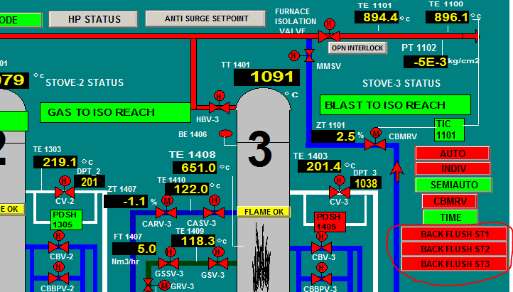

1. Back flushing operation shall be done in **Individual mode** of operation.

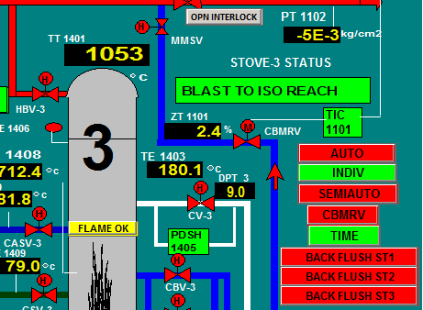

1. Select two stoves for which back flushing to be conducted. Please note that two stove has to be selected to commence the operation although doing back flushing for single stove.
2. Upon selection of Back flush button on SCADA page a Pop up will appear for password.

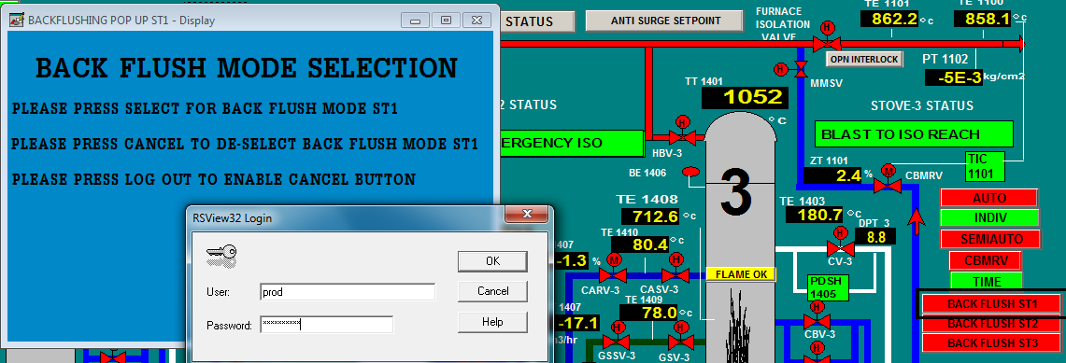

1. Put user name as **prod** password as **production**. Below screen will appear then press select.

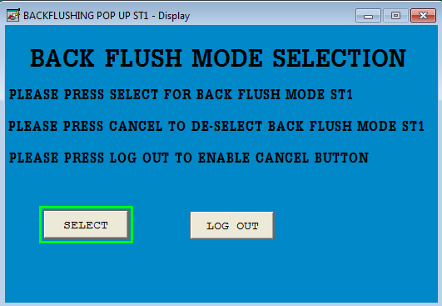

1. Back flush button of respective stove will become green. It means back flushing mode for that stove is enabled.

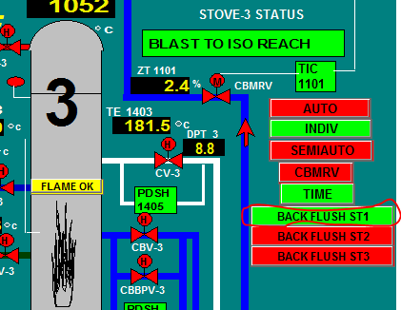

1. Repeat the procedure for selection of one more stove.

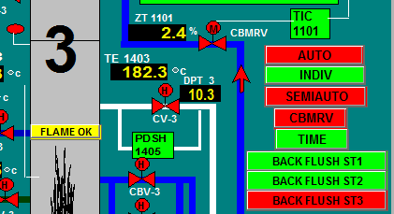

1. In this example ST 1 and ST2 is in back flush mode and ST3 to be taken for blast.
2. IVC should be fully closed, snort should be fully opened.
3. Now for doing back flushing of stove, first open the chimney valve then hot blast valve of that stove.
4. Now first open cold blast bypass valve, then open Hot blast valve, open col blast valve and then close cold blast bypass valve.
5. Now close the snort and start giving wind by opening the IVC as per requirement. Monitor the chimney temperature closely and continue the back flushing till it reaches 350 C. Back flushing can be discontinued as per production requirement when needed.
6. Now for discontinuing the stove back flushing first close the IVC fully, open the snort and ensure zero wind.
7. Then close the cold blast valve, hot blast valve of the stove in blast, hot blast valve of stove in back flushing, chimney valve of stove in back flushing in sequence.
8. Repeat the step 10 to 15 for doing back flushing of other stove.
9. After completion of all back flush activities operator must deselect the back flush tab on SCADA page. Please note without deselecting furnace isolation valve will not get opened. Login with password.

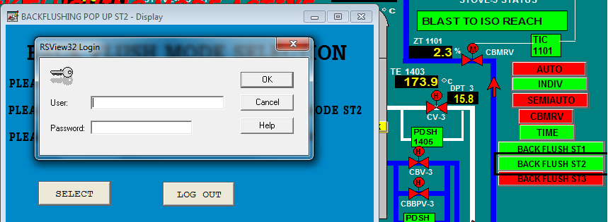

1. Press logout then cancel button will appear. Press cancel button to confirm the de-selection of back flush mode. Repeat the steps for other stoves as needed.

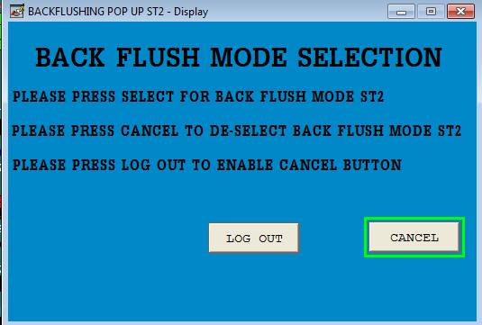

1. Upon pressing the cancel button, the back flush tab of respective stove will display red. The red display is confirmation that stove is no more in back flushing selection.

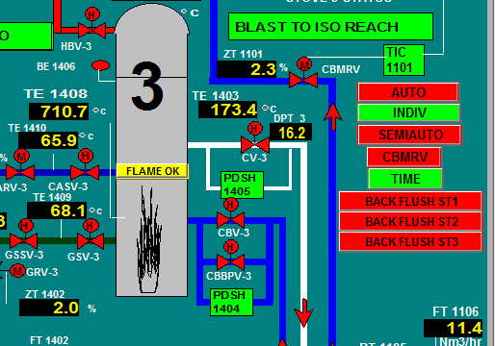

1. The back flush tab will automatically be disabled upon opening of furnace isolation valve.

|  |  |  |
| --- | --- | --- |
| Prepared By:  Head – Production PID I | Reviewed & Issued By:  Management Representative | Approved By:  Head – Pig Iron Division |
| Signature: | Signature: | Signature: |
| Date: **15.07.2022** | Date: **15.07.2022** | Date: **15.07.2022** |

|  |  |  |  |
| --- | --- | --- | --- |
| **Amendment Record** | | | |
| **Revision date** | **Manual Section ref. and para** | **Brief details of revision** | **New Revision No.** |
| 12.07.2021 | Procedure for Blower& Hot Blast Stove Operation (BF1 & BF2) | Point no 11, 12 | 10 |
| 15.07.2022 | Procedure for Blower& Hot Blast Stove Operation (BF1 & BF2) | Hazard revision &  Point 5 revised | 11 |